Lab 6 manual: Linear combination of resistors
Dr. D. Beznosko
5/1/2026
For PHYS 1112L only
(Lab outcomes: Solving a linear system of equations using computer.)

Abstract
The measurement of even a simple quantity like resistance can be difficult at times as it’s not always possible to separate the parts of the circuit for this measurement. The report describes the procedure of measuring the resistance of the inseparable circuit and suggests other possibilities for the measurements. Linear system of equations needs to be solved, and errors propagated.

Introduction
The solutions for the systems of equations are often needed in numerous practical applications. The most common example of linear system solution is the eigenvalue problem that is widely used in physics, engineering, and other sciences. It is at the base of machine learning. Can you find any more examples and practical uses?

Experimental Setup
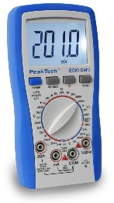
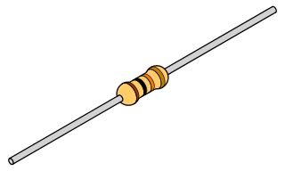
The experimental setup in Figure 1 shows the three resistors connected as a triangle. The resistance can be measured by the multimeter between the points A, B and C only.
R1
C
R2
R3
A
B
Multimeter

Figure 1: The experimental setup schematic. A multimeter is used to measure the resistance between the points A, B and C.

Procedure
Using multimeter, measure $R_{AB},R_{BC}∧R_{CA}$. Using the manual for the multimeter, get the accuracy and use it as systematic error. What is the statistical error? (Hint – if the digits don’t change, its half of the smallest digit. Otherwise, do the 5 measurements of one of the three resistances and use the stdev as statistical error).
In the theory section, write the expressions for $R_{AB},R_{BC}∧R_{CA}$ in terms of $R_{1},R_{2}∧R_{3}$. Can be left as reciprocal relationships, that is, $\frac{1}{R_{AB}},\frac{\frac{1}{R_{BC}}∧1}{R_{CA}}$.

Experimental Data
The results of the measurements should be organized as Table 1 or similar. Think about how to organize this table. The error can be listed in a different column or as value ± error unit. Don’t include all data values here, only relevant means, stdev etc. All additional data must be included in the Appendix for this lab. In most cases, all data points are not needed, especially for computer-based labs.
Provide description about each entry as needed, don’t just leave the table without text in this section. Organize well so that data takes up less space, but everything needed is included.
Table 1: Experimental data.
Quantity name | Measured value, units
R Measurement | Resistance, $Ω$
$$R_{AB}$$
 | Errors!

Analysis
Use the Wolfram Alpha [2] or similar computer software/online service to solve the system of equations for the $R_{1},R_{2}∧R_{3}$. Propagate errors and compare with the values of the resistors from the color marking. The marking has the %error, so each value is also with error. Do they match?

Conclusion
Comment on your result (that is, $R_{1},R_{2}∧R_{3}$) and the methods used to find it. What did you learn in performing this measurement? Where else can it be used? Can it be improved?

References

[1] | PASCO Scientific, 10101 Foothills Boulevard, Roseville, California 95747 USA.
[2] | "Wolfram Alpha," Wolrfam Inc., [Online]. Available: https://www.wolframalpha.com/.

Sample command: Solve[{1/r12 == 1/r1 + 1/(r2 + r3), 1/r23 == 1/r2 + 1/(r1 + r3), 1/r31 == 1/r3 + 1/(r2 + r1)}, {r1, r2, r3}], here r12 is for $R_{AB}$, etc.

